Date : 1st June 2020

To

The Director

Ghaziabad Branch Office

Bureau of Indian Standards

Central Laboratory (Chemical Lab Block), Ground & First Floor,

Plot No: 20/9, Site 4, Industrial Area Sahibabad, Sahibabad, Ghaziabad (UP) 201010

**Subject: Offering Letter of samples for Testing & Inspection (2 Lots)**

Sir

With reference to our application for license shifting of IS 374:2019 CM/L- 9616488 (Electric Ceiling type Fans & Regulators) with input power 50W & rating 230V, 50 Hz Single Phase ac, we are offering two lots of our product with following details.

|  |  |  |  |  |
| --- | --- | --- | --- | --- |
| S.No | Description of Sample | Lot No | Date of Mfg | Qty |
| 1 | Electric Ceiling type Fans & Regulators | 1 |  | 10 Set |
| 2 | Electric Ceiling type Fans & Regulators | 2 |  | 10 Set |

Further we undertake & declare that the above material manufactured by using our factory premises and it confirms to the relevant IS

Thanking You

Yours Faithfully

Authorized Signatory

(For Onkar engine & Generator Private Limited)

E-14, Sector 63, Noida (UP)

**Plant Location**

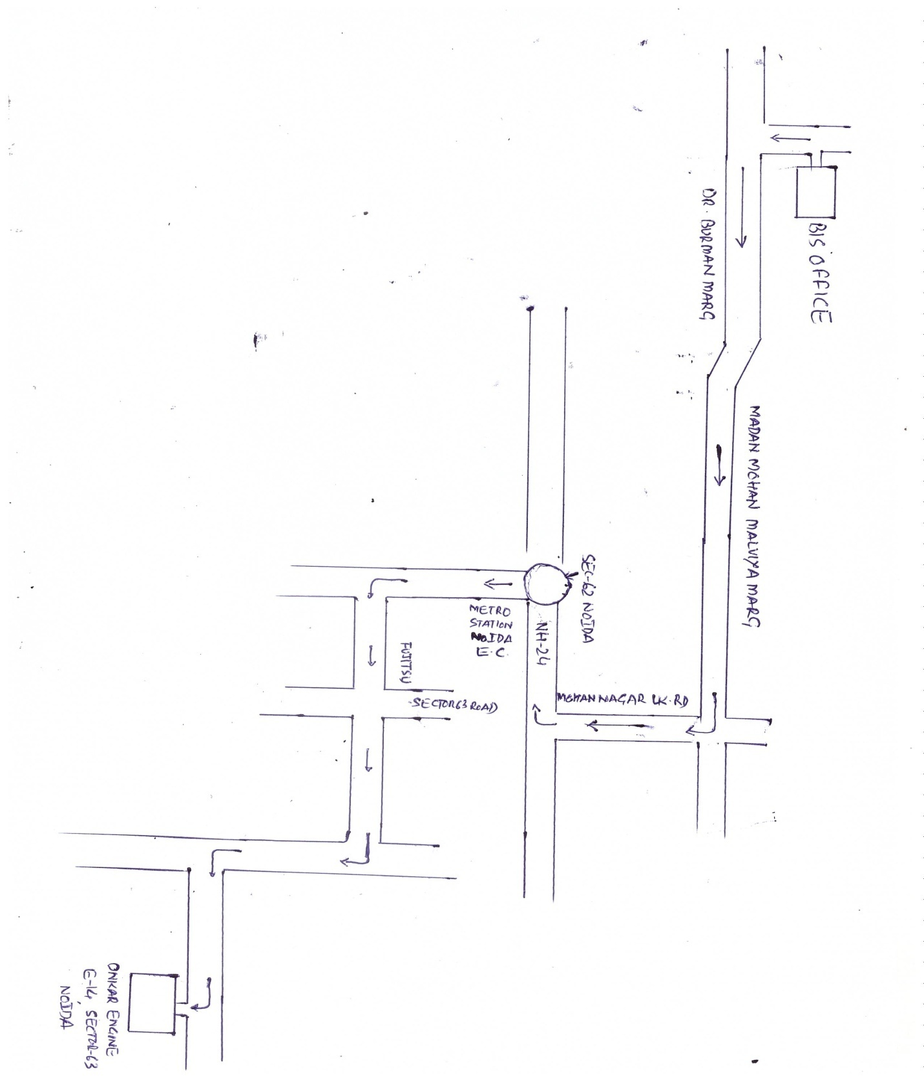

Date : 1st June 2020

To

The Director

Ghaziabad Branch Office

Bureau of Indian Standards

Central Laboratory (Chemical Lab Block), Ground & First Floor,

Plot No: 20/9, Site 4, Industrial Area Sahibabad, Sahibabad, Ghaziabad (UP) 201010

**Subject: Shifting of License**

Sir,

With reference to our license shifting request for our license IS 374: 2019 CM/L- 9616488 (Electric Ceiling Fan), we are submitting here the following documents for your kind perusal.

1. MSME Registration certificate
2. GST
3. Rent agreement
4. List of Manufacturing equipments
5. List of testing instruments
6. QCI details
7. Process flow chart
8. Plant Location
9. Plant layout
10. Lot offer letter

So kindly acknowledge the same.

“Thanking You”

Authorized Signatory

For Onkar Engine & Generator (P) Limited

E-14, Sector: 63, Noida (UP)

**DECLARED VALUE OF OUR PRODUCT**